### 

### Semester One Examination, 2023

### Question/Answer booklet

# MATHEMATICS METHODS

**UNIT 3**

## Section One:

## Calculator-free

|  |  |
| --- | --- |
| **Your Name:** |  |
| **Your Teacher’s Name:** |  |

## Time allowed for this section

Reading time before commencing work: five minutes

Working time: fifty minutes

## Materials required/recommended for this section

***To be provided by the supervisor***

This Question/Answer booklet

Formula sheet

***To be provided by the candidate***

Standard items: pens (blue/black preferred), pencils (including coloured), sharpener, correction fluid/tape, eraser, ruler, highlighters

Special items: nil

## Important note to candidates

No other items may be taken into the examination room. It is **your** responsibility to ensure that you do not have any unauthorised material. If you have any unauthorised material with you, hand it to the supervisor **before** reading any further.

|  |  |  |  |  |  |
| --- | --- | --- | --- | --- | --- |
| Question | Marks | Max | Question | Marks | Max |
| 1 |  | 7 | 4 |  | 9 |
| 2 |  | 6 | 5 |  | 8 |
| 3 |  | 15 | 6 |  | 6 |

**Structure of this paper**

|  |  |  |  |  |  |
| --- | --- | --- | --- | --- | --- |
| Section | Number of questions available | Number of questions to be answered | Working time (minutes) | Marks available | Percentage of examination |
| Section One:  Calculator-free | 6 | 6 | 50 | 51 | 36 |
| Section Two:  Calculator-assumed | 10 | 10 | 100 | 90 | 64 |
|  |  |  |  | **Total** | 100 |

**Instructions to candidates**

1. The rules for the conduct of the Western Australian Certificate of Education ATAR course examinations are detailed in the *Year 12 Information Handbook 2019*. Sitting this examination implies that you agree to abide by these rules.
2. Write your answers in this Question/Answer booklet.
3. You must be careful to confine your answers to the specific questions asked and to follow any instructions that are specific to a particular question.
4. Additional pages for the use of planning your answer to a question or continuing your answer to a question have been provided at the end of this Question/Answer booklet. If you use the space to continue an answer, indicate in the original answer space where the answer is continued, i.e. give the page number.
5. **Show all your working clearly.**Your working should be in sufficient detail to allow your answers to be checked readily and for marks to be awarded for reasoning. Incorrect answers given without supporting reasoning cannot be allocated any marks. For any question or part question worth more than two marks, valid working or justification is required to receive full marks. If you repeat any question, ensure that you cancel the answer you do not wish to have marked.
6. It is recommended that you **do not use pencil**, except in diagrams.
7. The Formula sheet is **not** to be handed in with your Question/Answer booklet.

**Section One: Calculator-free (51 marks)**

This section has **six** questions. Answer **all** questions. Write your answers in the spaces provided.

Spare pages are included at the end of this booklet. They can be used for planning your responses and/or as additional space if required to continue an answer.

● Planning: If you use the spare pages for planning, indicate this clearly at the top of the page.

● Continuing an answer: If you need to use the space to continue an answer, indicate in the original answer space where the answer is continued, i.e. give the page number. Fill in the number of the question that you are continuing to answer at the top of the page.

Working time: 50 minutes.

Question 1 (7 marks)

A function $f\left(x\right)$ has the derivative $f^{'}\left(x\right)={3x}^{2}+12x$.

(3 marks)

The graph has an $x$-intercept at $x=-1$.

1. Find $f\left(x\right).$
2. The graph has a point of inflection at $x=p$. Find $p.$

(2 marks)

1. Find the value(s) of $x$ for which the graph $y=f\left(x\right)$ is concave down.

(2 marks)

**Question 2 (6 marks)**

(a) Determine:

(i) $\int{3+cos⁡(3-2x) dx}$

(1 mark)

(ii) $\int_{3}^{4}{\left({(2x-5)}^{-2}\right) dx}$

(3 marks)

(b) (i) Determine the derivative of ${y=e}^{3x}(3x+5)$. Simplify your answer.

(2 marks)

Question 3 (15 marks)

At a mathematics camp, a student selects a counter from a bag containing 10 counters.

The counters are numbered from $1$ to $10$ inclusive. Depending on the outcome, the student wins Maths Dollars that can be spent on prizes.

(a) Complete the table showing the possible outcomes and the probability. (2 marks)

|  |  |  |
| --- | --- | --- |
| **Outcomes** | **Probability** | **Maths Dollars Won** |
| A multiple of $3$ |  | $$\$3$$ |
| A multiple of $4$ |  | $$\$9$$ |
| A multiple of $10$ |  | $$\$15$$ |
| All other numbers |  | $$\$x$$ |

A student pays $\$5$ to play the game

(b) Find the value of $x$ if the expected return on the game is $\$0$. (3 marks)

(c) Is the selection of a counter a Bernoulli trail? Justify your answer. (2 marks)

**Question 3** (continued)

The random variable $W$ is a Bernoulli distribution that models the situation from (a).

(d) Given that $Var\left(W\right)=0.16$, determine the probability of success and use the information in part (a) to what outcome is therefore considered to be a success. (2 marks)

The counter selected is returned to the bag, then the bag is shaken before the next student selects a counter. A student is interested in whether they win $\$15$ or not. They pay to play $10$ games.

Let $Y$ be the number of times the student wins $\$15$.

(e) State the distribution that would be used to determine the probability of $Y$.

(2 marks)

(f) The student performs the calculations given. Determine the number of times the student wins $15 in each of the following:

(i) $\left(\begin{aligned}10 \\ 2\end{aligned}\right){\left(\frac{1}{10}\right)}^{2}{\left(\frac{9}{10}\right)}^{8}$ (1 mark)

(ii) ${\left(\frac{9}{10}\right)}^{10}$ (1 mark)

(iii) $\left(\begin{aligned}10 \\ 4\end{aligned}\right){\left(\frac{1}{10}\right)}^{4}{\left(\frac{9}{10}\right)}^{6}+\left(\begin{aligned}10 \\ 5\end{aligned}\right){\left(\frac{1}{10}\right)}^{5}{\left(\frac{9}{10}\right)}^{5}$ (1 mark)

(iv) $1-{\left(\frac{9}{10}\right)}^{10}$ (1 mark)

Question 4 (9 marks)

The function $f(x)$ is defined for $x>1.5$, has derivative $f^{'}\left(x\right)=\begin{matrix}8 \\ \overline{{\left(2x-3\right)}^{2}}\end{matrix}$, and passes through the point $(4, 1)$.

(a) Determine the rate of change of $f'(x)$ when $x=3$. (3 marks)

(b) Determine $f(x)$. (4 marks)

(c) Determine $\begin{matrix}d \\ \overline{dt}\end{matrix}\int_{t}^{3}{\underset{ }{\left(f^{'}\left(x\right)-4x\right)}}dx$. (2 marks)

**Question 5 (8 marks)**

The probability function for the random variable $X$ is $P\left(X=x\right)=\left\{\begin{matrix}k^{2}-k+x, & x=0 \\ 5k^{2}x, & x=1 \\ 0, & \text{otherwise.}\end{matrix}\right.$

(a) Determine the value of the constant $k$. (4 marks)

(b) Determine the mean and variance of $X$. (2 marks)

(c) The random variable $Y=3X+1$. Determine the mean and variance of $Y$. (2 marks)

**Question 6 (6 marks)**

The region bounded by the $x$-axis and the graph of $y=sin⁡(x-\frac{π}{3})$, $0≤x≤π$ shown below is divided into two regions by the line $x=k.$

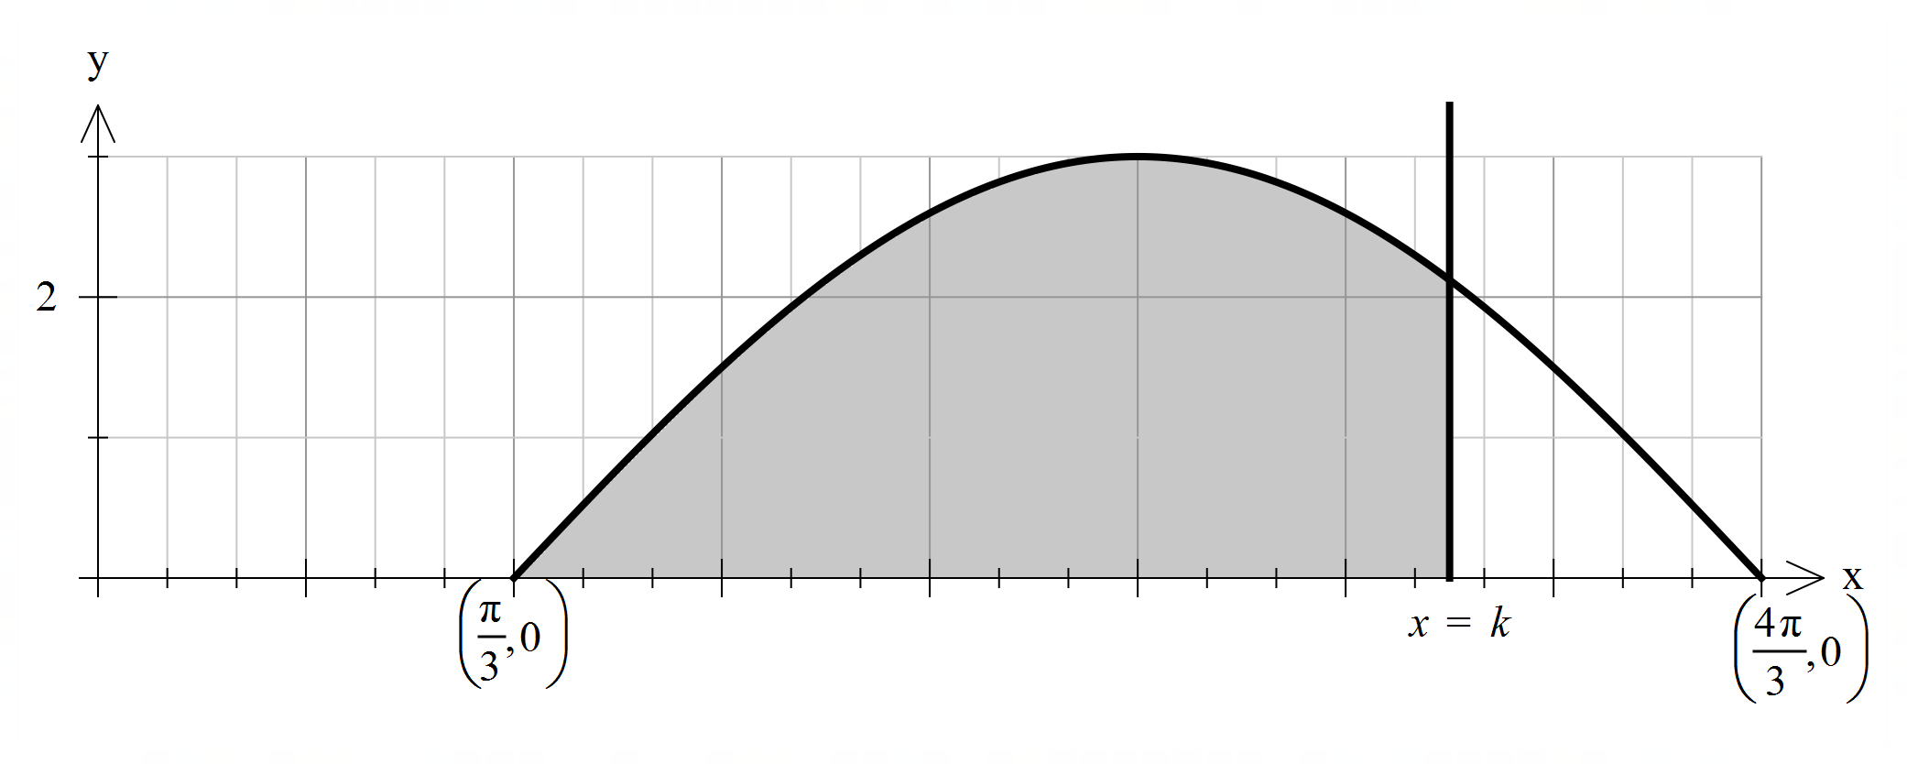

If the area of the region for $\frac{π}{3}≤x≤k$ is 3 times the size of the area of the region

for $k≤x≤\frac{4π}{3} ,$ determine $k.$

(6 marks)

Additional working space

Question number: ________

Additional working space

Question number: _____